cl- Chennai, nl- Chennai ,ctc – 4.80 lpa ( 4.12 I hand) ,np – 60 days , exp- 25% hike, intrumet cable, power , jumber upto 66

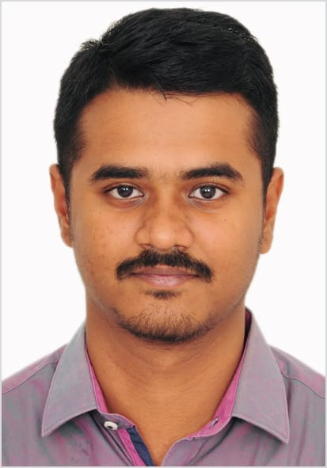
Karthik S
Technical Associate – Cables (Design, Costing, Buyer & Sales)
Looking for next level assignments for new learning and challenges with skill upgradations with overall mutual growth of organization and self.




https://www.linkedin.com/in/karthik13194. Phone: +918807431603

karthik.senthil@outlook.com. What’s app: https://wa.me/918807431603.
Residence: Plot No 6, 3rd Cross Street, Abirami nagar, Thiruninravur, Chennai 602024. INDIA

Work Experience
Employer: | Designation: | Tenure | Current Location
Siechem Technologies Pvt. Ltd. | Technical Associate | Oct 2016 – Till date | Chennai & Pondicherry

Responsible for:
The Primary responsibility of this job consists of analysis of customer specification and proposes a cable - Cable design, Accessories and Technical support to sales and offer management for 28 Segment including data cables.
The secondary key responsibility of this job is preparation of BoM/BoQ, Critical design information & detailed delivery program for all individual orders/Projects.
This additional responsibility of Buyer is Identifying vendor for other Brought out items/raw materials which is not in our product range & Floating RFQ – Collecting quotations, Identify alternative, equivalent components, datasheets & other terms and conditions for child parts. Negotiate with vendors if require to match the target price for win to win scenario.
Verify technical feasibilities, Alterations and Compliances for Existing products & NPD.
Identifying logistics provider to transport finished goods for import & export cargos.
Act as a one point of contact to assigned customer for write the calculation notes and modify till them fully approved from clients and generate cable construction and optimize the technical performance and other services.
Participate in meetings with clients when necessary & managing other activities like to promote our products/presentation, filing application for exhibition, Stall & room booking.
Negotiate and get work done to deliver project on time.
Coordinate with Internal & External Stockholders to follow up the deliverables.
Supervise the works of junior’s staff & provide necessary training.
Travelling if requires.
Recent Product development:
Contribute BOM & Development activity for Circuit Integrity Cables as per EN 50306 (Rolling Stock), EN 50264 (Rolling Stock), BS 50228-7(Control & Instrumentation cable for 90V, 300V & 500V), CAT5e, CAT6 & CAT7.
Strong knowledge in Automotive Specification & Battery Cable Specification ISO 6722 (Road Vehicles 60V to 600V Single core cable), Multicore cable 2TAD, 3TAD & 4TAD, ISO 19642 EV Cable Specification & Others JASO, JIS & DIN.
IEC 60502 – 1 Power cable, IEC 60092-353 Marine Cable, Powercord & Harness Assemblies.
Hybrid Cables & Composite cables, Conduits & End Fittings Accessories for Rollingstock.
Familiar with Appliances wiring Material for Indian Market (PVC Cable & XLPE Cable), Trirated cables for UK / European Market, Solar Cable
- Skill Set
Supplier Sourcing, Wires, Electrical Engineer (Able to read/write Shop floor drawings SLD, IFC, Schematics & Part model), Estimation, MEP (M&E), Project Planning & Management, Knowledge in Component/Equipment Selection and Hardware & Networking.
- Software Knowledge
ETAP*, Zuken E3*, AUTODESK (AutoCAD, REVIT), Relux, Proteus, MS Office (Word, Excel, PowerPoint, Outlook & Projects).
- Business Knowledge
Greeting Clients/Vendor when needed, Buyer activities, Vendor development, Freight-Incoterms, Liaise, Logistics, NPD (New Product Development), Managing file system, Communication - Handling incoming calls & Emails. Technical Support/Sales Support/Customer care/Export, Product Strategy, Team work, Time Management, Team Management, Presentation skills, Sales, Planning, Schedule, Resource allocation, Time Plan, Road Map, Negotiation, Sourcing, Planning, Forecasting, Setting Objectives and determine course of action, MRP, PPC & Costing.

Education Qualifications
Degree | Name of Institute | University / Board | Batch | Grade
B.E (EEE) +3 | Aalim Muhammed Salegh college of Engineering. Chennai-55 | Anna University – Chennai | 2016 | 6.32 CGPA
Diploma in EEE +3 | Aalim Muhammed Salegh Polytechnic college. Chennai-55 | Directorate of Technical Education - TN | 2013 | 79.25%
SSLC | Sir, M Ct M Boys Higher Secondary School. Chennai-84 | State Board of  Tamil nadu | 2009 | 50%

- Personal Details
Name: Karthik S
Father Name: Mr Senthil Nathan D
Date of Birth: 13-01-1994
Nationality: Indian
Marital status: Married
Languages: English & Tamil
Passport No: N8775309
- Declaration
I hereby declared all the information contained herein is true and correct to the best of my knowledge and belief.

Sincerely
Karthik S

